**ACKNOWLEDGEMENT**

I take this opportunity to express my deep sense of gratitude and sincere thanks to all who helped me to complete the work successfully. My first and foremost thanks goes to God Almighty who showered his immense blessings on my effort. I would like to express my sincere gratitude to **Mrs. Amarja Adgaonkar** (Head of the department), for her support and co-operation. I am deeply indebted to my guide, **Prof. Mrs. Shubhangi Verulkar** (Professor, Department of Electronic and Telecommunication Engineering) for her excellent guidance, constant encouragement, suggestions and constructive feedback in the completion of the seminar. I wish to express my sincere gratitude towards the staff members of our Department and Department Library. Finally I thank my parents, all my friends, near and dear ones who directly and indirectly contributed to the successful completion of this work.

|  |  |  |
| --- | --- | --- |
| **SR. NO** | **TOPIC** | **PAGE NO.** |
| A. | LISTOF FIGURES | i |
| B. | LISTOFTABLES | ii |
| 1. | Smart Dustbin Using Nodemcu PROBLEM DEFINITION  Aims and objectives Scope of the project Features of the project | 5  5  5  6 |
| 2. | Review of Literature | 7 |
| 3. | Implementation Methodology System Design  Block Diagram  Components/tools to be used components Actual photos of project  Conclusion and Future Scope | 8  8  9  10  12 |
| 4. | REFERENCE | 22 |
| 5 | Result(Video LINK) | 23 |

# List of Figure

|  |  |  |
| --- | --- | --- |
| Sr.No | Name of Figure | Page No. |
| 1 | Block Diagram | 10 |
| 2 | NodeMCU | 11 |
| 3 | Jumper Wires | 12 |
| 4 | Ultrasonic sensor | 13 |
| 5 | Implementation | 16 |
| 6 | Result | 17 |

**ABSTRACT**

Urbanization in towns and cities has grown multifold in the past few decades, with this rapid growth, waste production has also increased and is not being managed properly. Dustbins are used everywhere and are a necessity. Dustbins are overflowing and spilling waste material on the streets till the municipal corporation acts. With this paper, we hope to eradicate overflowing dustbins and aim to build a prototype of an automatic waste management system that will open its lid automatically after detecting people who want to throw out their trash, detect when it is full, not open its lid when it is full and notify the respective authority. The dustbins will be provided with an ultrasonic sensor that will track the level of garbage inside the dustbin and notify an authority via the BLYNK application. The aim of this paper is also to promote more research into waste management issues through IOT Based waste management using smart dustbin.

1. **INTRODUCTION**

In this project, we are going to make an **IoT based Dustbin**. You can check whether the dustbin is full or empty through a webpage. This dustbin updates its status in percentage in every 5 seconds, and when the dustbin is filled more than 70%, it sends an message that your dustbin is almost full.

We used an ultrasonic sensor and NodeMCU to build this **IoT dustbin project**. The ultrasonic sensor calculates the occupancy by detecting the trash in the dustbin. The distance between ultrasonic and trash is converted to percentage so that instead of showing two or three levels, we can show the dustbin status in percentage.

# LITERATURE SURVEY

|  |  |  |  |
| --- | --- | --- | --- |
| **Authors name** | **Machine learning methods** | **Data description** | **Performance** |
| Indira R. (2014) | fuzzy C- means | Speech signal dataset | 68.04% accuracy, 75.34% sensitivity and  45.83% specificity |
| Indira R. (2014) | ANN | Speech signal dataset | Recognition rate of 92 %. |
| R. Geeta (2012) | Classification | Speech dataset as high or low | Random tree classification 100%  accuracy |
| Rubén A. (2013) | Wrapper feat- ure selection | non-motor symptoms | 72% to 92% accuracy |
| Betalu E. (2014) | SVM | Age, gender, voice recording | 76%accuracy 34% sensitivity |
| A.Tsanas (2011) | SVM | Speech signal dataset | 98.6% accuracy |
| A.Tsans (2011) | Regression & Classification | Speech signal dataset | 5–95 percentile |
| Sharma A(2014) | SVM | Speech signal dataset | 85.29% accuracy |
| Khemphila (2012) | ANN | Speech signal dataset | 82.05% and 83.33%Accuracy |
| Revett (2009) | Correlation | Voice dataset | 100% accuracy |
| Shahbakhi (2014) | SVM | Speech signal dataset | 94.22% accuracy, 70.12% sensitivity and  92.8% specificity |

1. **PROBLEM STATEMENT**

Advances technology that grows rapidly to the present world, causes the company to provide a variety of programs to develop products based on the Internet of Things (IoT). IoT has a concept that evolves the benefits of being connected in an internet connection continuously. In the cleanliness sector, the role of the IoT is needed to overcome all the problems that exist in the detection of excessive garbage accumulation as early as possible, create efficiency and effectiveness of the garbage transport car in carrying out transportation. This project aims to modify the role of IoT with a sensor that will very useful to make Smart Dustbin.

The result show that IOT is useful for this Smart Dustbin. Smart Dustbin works well with high accuracy to control the accumulation of waste, so it can be a priority in transportation and excessive waste accumulation can be minimized.

# METHODOLOGY

### SYSTEM DESIGN

In this system, we have considered ultrasonic-level sensor takes to sense the level of waste in a waste bin, because during experiment it is found that ultrasonic 87sensorsprovide longer range than IR sensors. It is also found that the IR sensors get affected by sunlight, color of object and hardness of object. The intelligent sensor-based waste bin would estimate the level, weight of waste in it, presence of CO2 need to be detected and notifications need to be sent to the central management for appropriate action. The concept proposed uses ultrasonic-level sensor takes to sense the level of waste in a waste bin.



### 4.1.Block Diagram

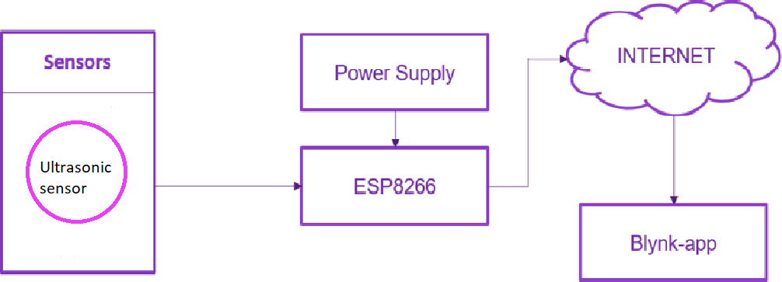

Figure no 4.1.1 : Block Diagram for Smart Dustbin

### Hardware Components

#### NodeMCU-ESP8266

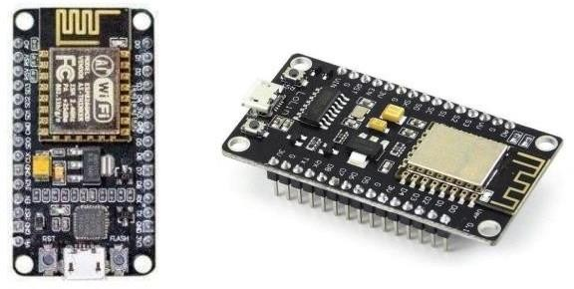

Figure no 4.2.1: NodeMCU – ESP8266

The NodeMCU (Node MicroController Unit) is an open-source software and hardware development environment built around an inexpensive System-on a-Chip (SoC) called the ESP8266. The ESP8266, designed and manufactured by Espress if Systems, contains the crucial elements of a computer: CPU, RAM, networking (WiFi), and even a modern operating system and SDK. That makes it an excellent choice for the Internet of Things (IoT) projects of all kinds. The ESP8266 WiFi Module is a self contained SOC with integrated TCP/IP protocol stack that can give any microcontroller access to your WiFi network. The ESP8266 is capable of either hosting an application or offloading all WiFi networking functions from another application processor. Each ESP8266 module comes pre- programmed with an AT command set firmware, meaning, you can simply hook this up to your Arduino device and get about as much WiFi-ability as a WiFi Shield offers (and that's just out of the box)! The ESP8266 module is an extremely cost effective board with a huge, and ever growing, community.

Ultrasonic Sensor :

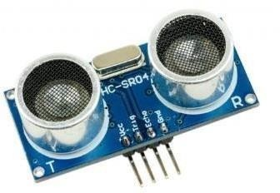

Figure no 4.2.2 : Ultrasonic Sensor

The ultrasonic sensor detects the level of garbage and sends a notification to the user via the Blynk application using NodeMCU if it reaches the specified level.

## Jumper Wires :

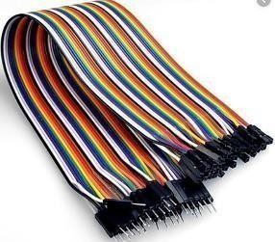

Figure no 4.2.3 : Jumper wires

Jumper Wires F to F

They are used to join different components and complete the circuit. They are also calledjumper wires and can connect an Nodemcu to sensors directly.

|  |  |  |
| --- | --- | --- |
| **Sr.**  **No.** | **Component** | **Requirement** |
| 1. | NodeMCU-ESP8266 | 1 |
| 2. | Ultrasonic Sensor | 1 |
| 3. | Jumper Wires | 10 |

# Code

**#**define BLYNK_TEMPLATE_ID "TMPLswhElqSM" #define BLYNK_DEVICE_NAME "Water"

#define BLYNK_AUTH_TOKEN "vhwAF6t69qoC_NBNqdyn6A1x8VfFllc2" #define BLYNK_PRINT Serial

#include <ESP8266WiFi.h> #include <BlynkSimpleEsp8266.h>

#define trig D2 #define echo D1

long duration; int distance; String show;

// You should get Auth Token in the Blynk App. char auth[] = BLYNK_AUTH_TOKEN;

// Your WiFi credentials.

// Set password to "" for open networks. char ssid[] = "int main()";

char pass[] = "INT456789";

BlynkTimer timer; WidgetLCD lcd(V1); void setup()

{

// Debug console

pinMode(trig, OUTPUT); // Sets the trigPin as an Output pinMode(echo, INPUT); // Sets the echoPin as an Inpu Serial.begin(9600);

Blynk.begin(auth," ONE", "1234@1234");

// Setup a function to be called every second timer.setInterval(1000L, sendSensor);

void loop()

{

Blynk.run();

timer.run();

}

void sendSensor()

{

digitalWrite(trig, LOW); // Makes trigPin low delayMicroseconds(2); // 2 micro second delay

digitalWrite(trig, HIGH); // tigPin high delayMicroseconds(10); // trigPin high for 10 micro seconds digitalWrite(trig, LOW); // trigPin low

duration = pulseIn(echo, HIGH); //Read echo pin, time in microseconds distance = duration * 0.034 / 2;

distance=(200-distance)-175;//Calculating actual/real distance

Serial.print("Distance = "); //Output distance on arduino serial monitor Serial.println(distance);

//lcd.print(0,0,"DusTBIN"); Blynk.virtualWrite(V0,(distance*100)/22);

if(distance<2){ show="Empty"; lcd.clear();

lcd.print(0, 0, "DUSTBIN is "+String(show));

}

if(distance>=5 && distance<11){

show="<Half"; lcd.clear();

lcd.print(0, 0, "DUSTBIN is "+String(show));

}

if(distance>=11 && distance<17){ show=">Half";

lcd.clear();

lcd.print(0, 0, "DUSTBIN is "+String(show));

if(distance>=20){ show="Full"; lcd.clear();

lcd.print(0, 0, "DUSTBIN is "+String(show));

}

// use: (position X: 0-15, position Y: 0-1, "Message you want to print") lcd.print(0, 1, "Distance: " + String(distance) + "cm ");

delay(1000);

}

# ACTUAL PHOTOS OF PROJECT



Figure no 4.3.1 Empty Dustbin Image

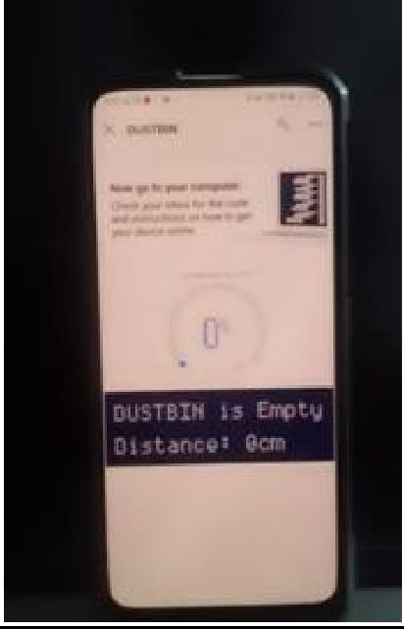

Figure no 4.3.2 : Dustbin showing empty on Blynk App

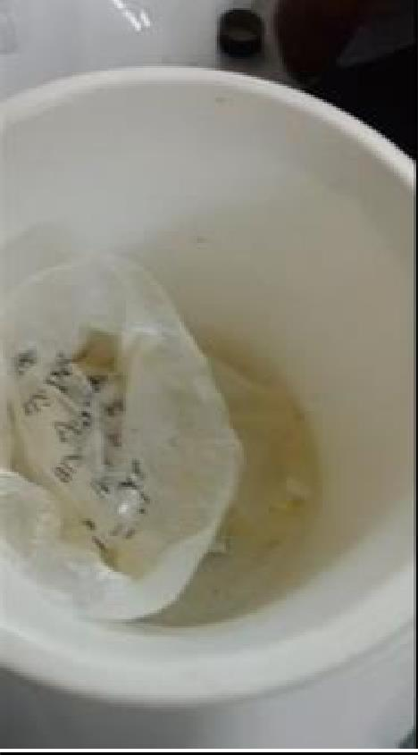

Figure no 4.3.3 Half Dustbin Image

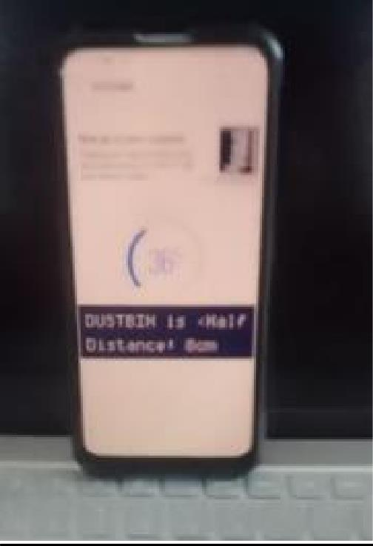

Figure no 4.3.4 Dustbin showing half on Blynk App

# Blynk Application:

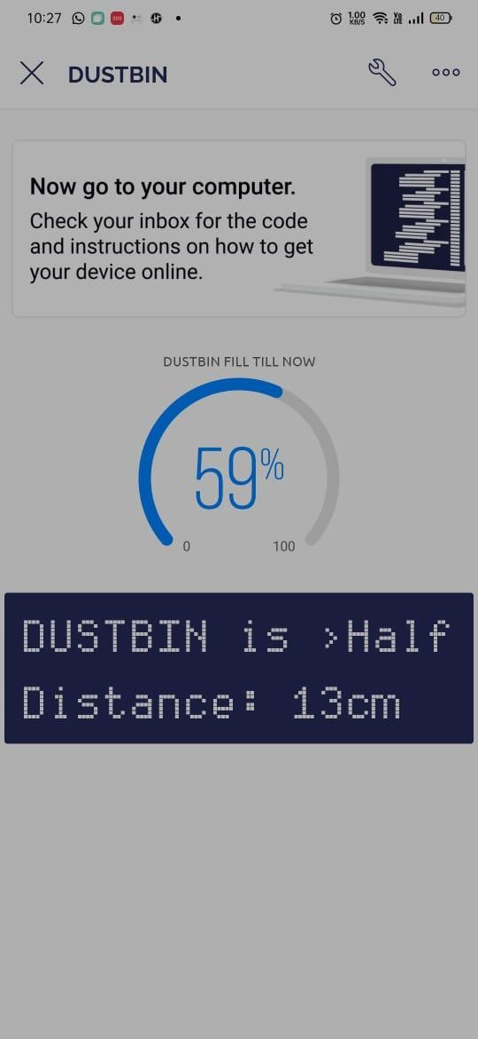

Figure no 4.4.1 : It shows that the dustbin is 59% occupied through blynk app. The Distance of the Dustbin is 13 centimeter. It shows DUSTBIN >Half

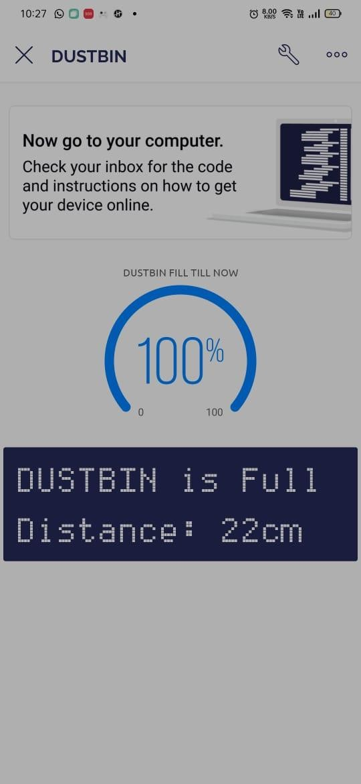

Figure no 4.4.2 : It shows that the dustbin is 100% occupied by the blynk app. The distance of the dustbin is 22 centimeter.

# CONCLUSION & FUTURE SCOPE

This system and application are designed and built to integrate waste collection sites with the system, making it easier for users to monitor waste collection sites so that there is the anticipation from related parties and there is no excessive waste accumulation. This monitoring system is made using Node-MCU as a control, ultrasonic sensor as This system works well with high accuracy and can be used for the smart city concept.

Here we are going to make an evolution change toward cleanliness. The combination of intelligent waste monitoring and trash compaction technologies, smart dustbins are better andshoulders above traditional garbage dustbin.

For social it will help toward health and hygiene, for business for we try to make it affordableto many as many possible. So that normal people to rich people can take benefit from it.

Raspberry Pi can also be used for the same application, because of its vast image processing libraries.Moreover, optional Memory to store all the captured videos /images in the Raspberry Pi ishigher compared to other controllers.Believe this will bring something changes in term of cleanliness as well technology.

# References

1. InsungHong,SunghoiPark,BeomseokLee,JaekeunLee,DaebeomJeong, andSehyunPark, “IoT- Based Smart Garbage System for Efficient Food Waste Management” -Scientiﬁc World Journal- Aug 2014.
2. Ala Al-Fuqaha, Mohsen Guizani, Mehdi Mohammadi, Mohammed Aledhari, MoussaAyyash,“Internet of Things: A Survey on Enabling Technologies, Protocols and Applications” -IEEE- 2015.
3. TheodorosAnagnostopoulos,ArkadyZaslavsky ,Alexey Medvedev, “IRobust Waste Collection exploiting Cost Efficiency of loT potentiality in Smart Cities”-IEEE-April-2015.
4. Vikrant Bhor1, Pankaj Morajkar2, Maheshwar Gurav3, Dishant Pandya4, AmolDeshpande, “Smart Garbage Management System” -March 2015.
5. Dario Bonion, Maria Teresa Delgado Alizo, AlexandreAlapetite, Thomas Gilbert, MathaisAxling,HelenUdsen, Jose Angel Carvajalsoto, Maurizio Spirito, “ALMANAC: Internet Of Things for Smart Cities” - IEEE-2015.
6. FachminFolianto, Yong Sheng Low,Wai Leong Yeow, ”Smart bin: Smart Waste Management System” -IEEE-April 2015.
7. KristýnaRybová, Jan Slavík, “Smart cities and ageing population– Implications for waste management in the Czech Republic “ -IEEE 2016.
8. Jose M. Gutierreza, Michael Jensenb, Morten Heniusa and TahirRiazc, “Smart Waste Collection System Based on Location Intelligence”- IEEE 2015.
9. Álvaro Lozano Murciego, Gabriel Villarrubia González, Alberto LópezBarriuso, Daniel Hernández de La Iglesia, Jorge RevueltaHerrero and Juan Francisco De Paz Santana, “Smart Waste Collection Platform Based on WSN and Route Optimization “-2016.
10. Theodoros Anagnostopoulos1, Arkady Zaslavsky2,1, Alexey Medvedev1, Sergei Khoruzhnicov1, “Top–k Query based Dynamic Scheduling for IoT-enabled Smart City Waste Collection” -IEEE-2016.
11. Clarabellejoanna ,Sathiyavathi.R, “Quota based routing protocol in disruption tolerant networks”,in International conference on information communication embedded systems (icices2014)”, Isbn no.978-1- 4799-3834- 6/14©2014.
12. SandeepSauravSingh,Y.BevishJinila,” Sensor Node Failure Detection using Check Point Recovery Algorithm”, Fifth International conference on recent trends in Information Technology (ICRTIT 2016)”, pp.1-4, 10.1109/ICRTIT.2016.7569585.

13.Y. BevishJinila, K. Komathy, “Rough Set Based Fuzzy Scheme for Clustering and Cluster Head Selection in VANET”, ELEKTRONIKA IR ELEKTROTECHNIKA, Vol.21, No.1, pp.54-59, ISSN : 1392- 1215,2015.

14.Y. BevishJinila, “Anonymization based location privacy preservation in Vehicular ad hoc networks”, Vol.8, No.1-4, pp.109-114, ISSN : 1313-6569, 2015.

### 6.RESULT :

Video Link :

https://drive.google.com/drive/folders/1U5tZoZUf7QoId1_FlHoPRUn9DspG38qO